Proposal for a joint CMB B-polarization and Sunyaev-Zel’dovich measurement in space

Final report presented to the Alpbach Summer School on Dark Matter and Dark Energy

28 July 2005

Laila Alabidi¹, Paul Beck², Marcos Cruz³, Árdís Elíasdóttir⁴, Henning Gast⁵, Lara Rodrigues da Costa Gomes de Sousa⁶, Thomas Kronberger⁷, Gemma Luzzi⁸, Jens Melinder⁹, Peter Predehl¹⁰, Oliver Preuß¹¹, Mirko Tröller¹², Elisabetta Valiante¹⁰, and Paul Anthony Ward¹³

¹ Physics Department, Lancaster University, United Kingdom
² Institut für Astronomie, Universität Wien, Austria
³ Instituto de Fisica de Cantabria, Universidad de Cantabria, Spain
⁴ Niels Bohr Institute, University of Copenhagen, Denmark
⁵ I. Physikalisches Institut B, RWTH Aachen, Germany
⁶ Faculdade de Ciéncias, Universidade do Porto, Portugal
⁷ Institut für Astrophysik, Universität Göttingen, Germany
⁸ Department of Physics, University of Rome “La Sapienza”, Italy
⁹ Department of Astronomy, Stockholm University, Sweden
¹⁰ Max-Planck-Institut für Extraterrestrische Physik, Garching, Germany
¹¹ Max-Planck-Institut für Sonnensystemforschung, Katlenburg-Lindau, Germany
¹² Metsähovi Radio Observatory, Helsinki University of Technology, Finland
¹³ School of Cosmic Physics, Dunsink Observatory, Dublin, Ireland

Abstract
We propose a space mission to precisely map the B-polarization of the Cosmic Microwave Background (CMB). As a secondary target, the same observatory is to conduct an all-sky survey of galaxy clusters using the Sunyaev-Zel’dovich effect (SZE).
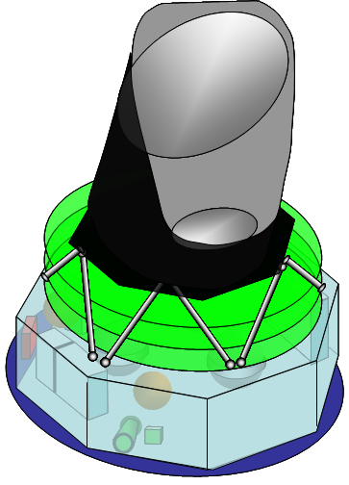

Introduction
Dark matter and dark energy govern the structure and evolution of the Universe. In fact, we know today that they represent about 96% of the energy density at the present epoch. Understanding their behavior and nature is crucial to have a complete cosmological picture of our Universe.

The SUnyaev-Zel’dovich b-Polarization ExploRing Microwave ANtenna (SUPERMAN) experiment we propose plans to follow in the footsteps of COBE, WMAP and PLANCK and take CMB measurements to the next level. We plan to focus on measurements of the B-polarization of the CMB background. A signal of this has yet to be measured and PLANCK is not likely to make a detection due to lack of sensitivity. We therefore mean to significantly improve the sensitivity of the polarimeters. We do this both by increasing our number of detectors and increasing the mission lifetime to five years. Ground-based missions can reach competitive sensitivity to ours, however, to study the low modes of the polarization (the reionization bump, an effect of dark matter annihilation), an all sky coverage is essential and will not be reached by any planned ground mission.
A secondary effect in the CMB spectrum is the Sunyaev-Zel’dovich effect. To measure this effect, one needs very high resolution (of the order of 1’) which has so far only been achieved in ground-based measurements with limited sky coverage. We however propose to do an all sky survey with resolution of 1’ which will give a catalogue with a well understood selection function which can be combined with results from all sky X-ray surveys (such as ROSITA).
After building the scientific case for the measurements we want to conduct, the instrument is described. An outline of the mission that will carry the instrument into space concludes this article.

Scientific case for B polarization measurement in space

Introduction to primordial B-mode polarization
The cosmic microwave background (CMB) only acquires its polarization by Thomson scattering, post photon decoupling, and yet more after re-ionization. The amount of polarization along a certain direction k is dependant on the (free) electron density in that direction. It was usually assumed that the electron density was uniform in a plane perpendicular to k thus generating only linear E-mode polarization. However, a tensor perturbation, i.e. gravitational waves, will lead to an in-homogeneity in the electron density in these planes, thus leading to phase shift in the photons arriving from different directions. This in turn leads to B-mode polarization with amplitude $U\text{=<}2E_{x}E_{y}\text{cos}(δ_{1}−δ_{2})>$, where $E_{x},E_{y}$ are the amplitudes of the light for the x and y directions, and $(δ_{1}−δ_{2})$is the phase difference between the two photons.

Motivation for more precise measurement of the B-mode
We recommend the use of CMB polarization analysis as a means of probing dark matter and dark energy in the Universe, as the measurement of the primordial power spectrum is a “linear calculation based on well understood physics” (Padmanabhan and Finkbeiner), and as B-modes are a strong indication of primordial dark energy, this would be an indication for a non-constant cosmological constant (Quintessence). An accurate measurement of primordial B-mode polarization, the existence of which is supported by results from WMAP, will offer not only an amazing insight to an era of our universe as yet unobserved but will also confirm or refute magnetic parity conservation (B-modes are expected to have (-1)^{l+1}). If the temperature anisotropies are indeed the cause of the density perturbations, then they will be polarized, and a direct measurement of these modes would be a powerful way of determining whether they are indeed primordial or simply the result of some as yet unknown evolution. Since the primordial B-mode polarization of the CMB arises from the tensor perturbations in space-time, detection would be an indirect measurement of primordial gravitational waves. Added to which the measurement will give us a stronger constraint, or a value in the optimistic case, on the tensor to scalar ratio r this will give unparalleled information on the type and energy scale of the inflationary potential. It will also shed light on the physics of energy scales inaccessible to particle accelerators and can be a probe of quantum gravity. B-modes also offer a more precise probe into the re-ionization history, and should illuminate the unexpected thickness of the optical depth as measured by WMAP, a phenomenon which is attributed to dark matter annihilations (Padmanabhan and Finkbeiner).
Until recently, not only the B-mode polarization but also r have been neglected by cosmologists as being either too small to detect, or simply nonexistent. It has only been recently (since WMAP) that a renewed interest in these parameters and their cosmological implications has begun. An accurate measurement of these modes will give us insight to an even earlier epoch of our universe, and allow us the closest view ever of inflation.

Necessity for going to space
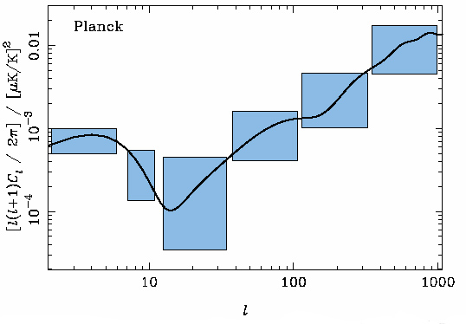
A satellite on orbit around L2 would have a very stable environment; as such system noise will be greatly reduced compared to Earth and balloon-based missions, which must deal with disturbances from both the atmosphere and the Earth itself. As the system noise is one of the main limitations on our detection sensitivity, this will help increase our sensitivity.
Figure 1: Expected shape of the power spectrum for B-modes.
All sky coverage is crucial to B-mode polarization measurements for two reasons. The first reason is that it improves the statistics. Even more importantly, all sky coverage is imperative for detecting the lowest polarization modes (l < 20) which probe the reionization bump resulting from dark matter annihilation.

Observables and fluxes
Essentially, we wish to measure the intensity of the B-mode flux from the CMB, which has a homogeneous temperature of 2.728K across the sky, with a temperature anisotropy of: $\frac{δT}{T}≈{\text{10}}^{−5}$(Verde et. al.) with the Stokes parameter$I≈\text{11}⋅{\text{10}}^{−6}\frac{W}{m^{2}}s$, where $\text{Intensity}=\frac{I⋅dω}{4}\frac{W}{m^{2}}$. Since the primordial signal is not predicted by theory, we need to rely on numerical simulations and parameter fitting (using the Boltzmann code CAMB and RECFAST), combined with a study of previous experiments such as WMAP to get a maximum value of the tensor to scalar ratio. Verde et. al. show that the signal needs to be distinguishable from a noise background of 2.2μK, and (Hu and White) demonstrate (Error: Reference source not found) that the expected maximum amplitude of B-polarization fluctuations is on the order of 1μK.

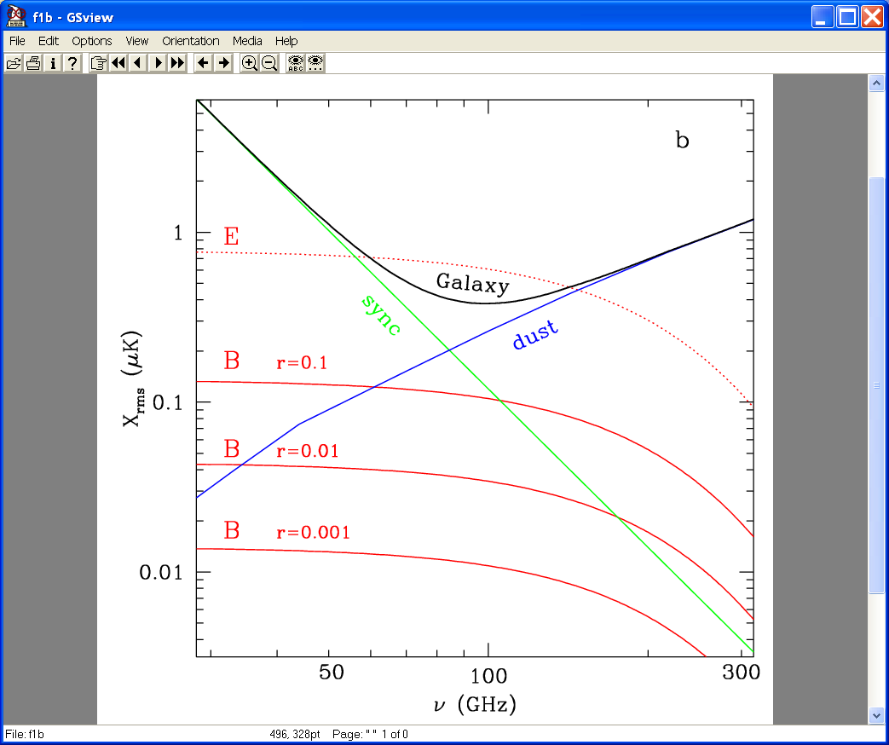
Foregrounds and systematic effects
Figure 2: Expected foreground emission for various frequencies.
CMB foreground emission will dominate the signal at all frequencies. The polarized foregrounds are due to free-free, synchrotron and dust emission as well as extra-galactic sources (Verde et al., 2005). As free-free polarization is expected to be negligible, our main galactic concerns are the dust and synchrotron emission. The dust emission is strongest at high frequencies and the synchrotron emission at low frequencies (Error: Reference source not found). The minimum emission occurs at around 100 GHz for FWHM=1° resolution (Tucci et al.(2005)). We therefore wish to make measurements in low and high frequency channels to deduce the foreground emission and an intermediate channel (100 GHz) to get the best signal for the B-polarization.
The main extragalactic foreground signal is from radio galaxies and weak lensing. The radio galaxy signal is a strong constraint for a low resolution experiment, but with our expected resolution, we should be able to subtract the signal without comprimising our goal of r=0.001 detectability. Different approaches have been suggested for removing the weak lensing signal (Knox & Song, (2002), Kesden et al., (2002), Seljak & Hirata, (2003)) and they all show that a high precision can only be reached for low-noise experiments with arcminute resolution such as in our case. Here we will clearly outdo PLANCK or other lower resolution experiments.

Complementarity and competition
There are at least eight ground-based, balloon-borne and space missions planned to measure the B-mode polarization of the CMB within the near future. Current space missions like WMAP do not have enough sensitivity to measure the B-mode. Even PLANCK will only be able to measure it in the most optimistic case and with huge error bars. The most promising ground-based or balloon-based experiments (CLOVER, QUIET, EBEX) are supposed to reach a sensitivity of only r~0.005 (Taylor et al., 2004) even by using new bolometer technology. However, we intend to use an enhanced version of this detector technology in our proposed space mission. In addition to the advantage of full sky coverage, our experiment is therefore expected to reach a sensitivity of r~0.001. This is consistent with the expectations by Verde et al. (2005) under the assumption of a markedly improved knowledge of polarization foregrounds. One disadvantage of ground-based and balloon-borne experiments is the limited observed area which constrains the detectability of the B-mode, due to the cosmic variance on the lower multipoles. In addition, atmospheric disturbances limit the sensitivity of ground-based and balloon-borne experiments.
A comparable mission dedicated to the measurement of CMB polarization is proposed within NASAs “Beyond Einstein” program. However, since the measurements of the B-mode polarization within our program are complemented by measurements of the SZ effect, our mission is scientifically superior to the NASA probe. Our sensitivity is roughly 20-100 times that of the HFI focal plane detector on PLANCK and therefore exceeds the sensitivity of typical ground-based and balloon-borne experiments by at least an order of magnitude.

Scientific case for an Sunyaev-Zel’dovich-effect cluster survey in space

Introduction to SZE
The Sunyaev-Zel’dovich effect (Sunyaev & Zel’dovich 1970, 1972) is a very powerful observational tool to study the large scale structure of the universe. It is a small spectral distortion of the cosmic microwave background (CMB) caused by inverse Compton scattering of the CMB photons off the electrons in the hot gas in clusters of galaxies. Expressed as a temperature change, the SZE at dimensionless frequency $x≡\frac{hυ}{k_{b}T_{\text{CMB}}}$ is given by (e.g. Birkinshaw (1999)):
$\frac{{ΔT}_{\text{SZE}}}{T_{\text{CMB}}}=f(x)y=f(x)\int{n_{e}}\frac{k_{b}T_{e}}{m_{e}c^{2}}σ_{T}\text{dl},$
where y is the Compton y-parameter, σ_{T} is the Thomson cross-section, n_{e} is the electron number density, T_{e} is the electron temperature, k_{b} is the Boltzmann constant, m_{e}c² is the electron rest mass energy and the integration is along the line of sight. Typically, these spectral distortions of the CMB are of order ~ 0.1mK.
As it is insensitive to the redshift of the galaxy cluster, it allows us to study the evolution of the abundance and the spatial distribution of clusters at all redshifts. Especially for high redshifts (z>1), the SZE is a powerful probe of cosmology, highly complementary to other observational diagnostics of galaxy clusters such as X-ray measurements and gravitational lensing. There is an additional spectral distortion if the cluster is moving with respect to the CMB restframe. This kinetic SZE is much smaller than the thermal SZE described above but is a unique tool to large scale velocity fields at high redshift.
From the local extrema in the spectral shape as given by f(x), it is clear that the thermal SZE is most pronounced at frequencies around 143GHz and 330 GHz, while the kinetic SZE peaks around the null of the thermal SZE, at 220 GHz. The angular size of clusters at high redshift leads to a desired angular resolution of around 1’.

Scientific yield from an SZE cluster survey
The proposed mission offers the opportunity to obtain an all-sky catalogue of galaxy clusters up to high redshifts of z ~ 2-3 for the first time. This promises to greatly improve both our knowledge of structure formation in the universe, leading to constraints on the cosmological parameters, and the physics of galaxy clusters, as will be described in the following paragraphs (Carlstrom et al., 2002).
The Hubble parameter H₀ is the most important cosmological parameter, as it sets the scale for all of cosmology. The combination of SZE and X-ray measurements of a galaxy cluster gives a unique way to determine the angular diameter distance D_{A} of the cluster – completely independent of the usual method involving the cosmic scale ladder. This is done by exploiting the different electron density dependencies of the SZE and X-ray emissions. Given the redshift of the clusters, one can then obtain H₀ by fitting the theoretical angular diameter distance relation to the D_{A}(z) distribution of the clusters, in which H₀ acts as a normalization.
Galaxy clusters trace the distribution of matter in the universe, and thus, the evolution of their abundance is a powerful probe of cosmology. An SZE survey is especially suited for this because of the independence of the SZE on redshift, which in turn leads to a mass selection function remarkably uniform in redshift. Measuring the cluster masses and number densities as a function of redshift will allow interesting constraints to be put on the matter and dark energy densities Ω_{M} , Ω_{Λ} , as well as σ₈, the present linear-theory mass dispersion on a scale of 8 h⁻¹Mpc. Additionally, for a sufficiently large sample, the equation of state of the dark energy can also be probed and the time dependence of the dark energy fraction investigated. This would constitute a test of quintessence models (Bartelmann et al., 2005).
Since the baryonic mass in the inter-cluster medium by far outweighs that in the galaxies themselves, the gas mass fraction f_{g} can be used as a reasonable approximation of the universal baryon mass fraction Ω_{B} / Ω_{M}. Given Ω_{B} , for example from an analysis of Big Bang nucleosynthesis, one can thus constrain Ω_{M}. Observations of the SZE directly yield the gas mass of a cluster, provided its electron temperature is known. Combining this with X-ray or weak lensing studies of total masses gives a way to determine the gas mass fraction.
Inflationary models of the early universe predict predominantly Gaussian primordial density fluctuation. Any deviation from this behaviour will result in an excess of high-mass clusters at high redshifts. These can however only be found in SZE surveys while they will be missed in X-ray surveys.
Currently, the only known way to measure large scale velocity fields at high redshift is by means of the kinetic SZE. Though this effect is small, averaging over many clusters will allow the determination of mean peculiar velocities on large scales.
Another application of the SZE, discussed rather recently, is the study of superclusters (Diaferio et al., 2003) and of the intra-supercluster gas (Sadeh & Raphaeli, 2005). This will give information on the largest scales, which are hardly accessible with other observational methods.

Necessity for going to space
The frequency range used for an SZE survey is adjacent to that needed for the B polarization measurement. Since the same type of detector can be used for both observations, the two scientific goals can be addressed using the same satellite, thus dramatically improving the cost to yield ratio.
The detection limit for an SZE survey is basically set by the mass of the cluster, independent of redshift. Therefore, the most powerful use of the SZE are deep, large scale surveys, which lead to a cluster catalogue with a well understood selection function. Obviously, full sky coverage is best suited to fully exploit the possibilities of the SZE. Especially as soon as X-ray all sky surveys are available, e.g. ROSITA (Predehl et al. (2003)), a deep all sky SZE survey is necessary to combine the two complementary measurements with high statistics. In addition, ground based observations, though having high spatial resolution, suffer from systematics such as atmospheric variations and an increased opacity of the atmosphere at higher frequencies.

Foregrounds and systematic effects
In the frequency range covered by our instrument, SZE signals must be separated from other infrared emissions. The major source of contamination are point sources, for example dusty star-forming galaxies at high redshift, shining brightly in the sub-mm range.
For the determination of the Hubble parameter, the selection effect, the assumption of isothermal β-model and unclumped gas distribution must be considered as systematic uncertainties. Uncertainties in the electron temperatures constitute the largest contribution to the systematic error on the gas mass fraction. The gas dynamics of clusters needs to be understood and the mass detection limit determined. Conducting high-resolution SZE, X-ray and weak lensing observations, as well as numerical situations will help to fully realize the potential of the SZE cluster survey.

Complementarity and competition
As a follow-up mission to COBE and WMAP, the PLANCK surveyor mission will probe the cosmic background radiation. Its ability to measure the SZE will however be severely hampered by its low angular resolution of only 5’ at high frequency, compared to the 1’ needed for a deep survey. In addition, the sensitivity of the proposed mission will be higher than that of PLANCK.
The Atacama Cosmology Telescope (Kosowsky (2004)), currently in the development stage, will perform an SZE survey from the ground. But this will naturally cover only a limited patch of the sky and not exceed a frequency of 270 GHz.

Expected results
The number of clusters expected to be found by a SZE survey sensitively depends on the cosmological model and on the detector specifications. Estimates require especially the number density of clusters as a function of mass and redshift. This quantity can be either estimated using the Press-Schechter formalism (Press & Schechter 1974), which is based on the statistics of peaks in Gaussian random fields, or by numerical simulations. The latter method has the advantage that also the physics of the ICM and systematic effects can be modelled in detail. Our estimate of source counts is based on hydrodynamical simulations by da Silva et al. (2000). The expected number of clusters detected in our survey is presented in Table 1.
Cosmological model | Clusters per square degree | All sky survey yield
ΛCDM | 20 | 700000
τCDM | 3 | 105000
Table 1: Expected number of clusters detected.

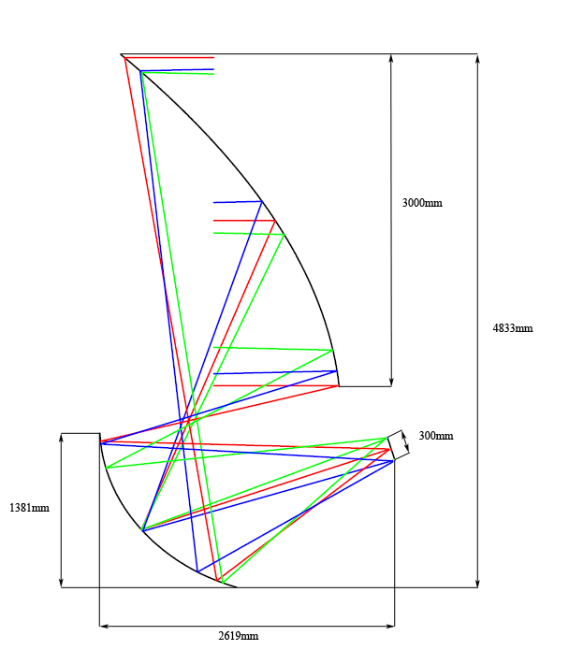
Description of the experiment
Figure 3: Raytracing schematic of a 3m off-axis system. The telescope is an offset Gregorian satisfying the Mizuguchi-Dragone condition. The aperture stop is the primary mirror.

The telescope
The measurement of signals as faint as the CMB polarization B-mode needs very high sensitivity, reachable using large-format arrays of detectors, which in turns mandates the use of telescopes with a large field of view. Moreover, a clean and well defined beam with low sidelobes and high efficiency is desirable and this is achievable with unblocked apertures.
The desire of unobstructed and large apertures leads naturally to off-axis reflector design. In particular, we are going to use an off-axis tilted Gregorian system where the eccentricity and tilt angle of the secondary mirror and the off-axis angle obey the Dragone-Mizuguchi condition (Mizuguchi et al., 1978; Dragone, 1982). In this system, both astigmatism and coma are eliminated. Moreover, this design greatly reduces instrumental polarization and has a large field of view (~ 24 sq.deg.) (Hanany and Marrone, 2002).
On the other hand, detection of clusters at high redshift requires an angular resolution of ~1 arcmin for the highest frequency, corresponding to a wavelength of 1.1 mm. This requires a 3m diameter primary mirror (Error: Reference source not found). In this way, we are diffraction limited for all the frequencies.
Radiation will be coupled from the telescope to the detectors via conical feedhorns (Error: Reference source not found). They are designed to provide low sidelobe level, low loss, and good stability. Their position on the focal plane will be chosen to illuminate the primary mirror not uniformly, but following a Gaussian function. In this way, the detectors will not see sidelobes form the telescope.

The instrument
The PI/TI (Polarising Instrument/Total intensity Instrument) will observe the CMB in six channels: 40GHz, 100GHz, 220GHz for the PI and 143GHz, 220GHz, 330GHz for the TI. The PI is specifically tailored for the detection of the B-mode polarization, while the TI will be used for the observation of the SZ effect. The detector system for each channel will involve an array of individual horn waveguides, which pass through band limiting filters and are then detected using an array of bolometers. This signal is then read out using SQUIDs.
Transition edge sensors
The focal plane array will use horn-fed spider-web bolometers with superconducting Transition-Edge Sensors (TES), see Error: Reference source not found and Error: Reference source not found. Compared with conventional semiconductor-based technologies, TES detectors offer several advantages for the construction of large arrays (Oxley et al., 2005). First, the bolometers are produced entirely by thin film deposition and optical lithography, greatly simplifying fabrication and improving the uniformity of the devices. Secondly, readout multiplexing technologies have been developed for TES detectors that have the potential to greatly reduce the complexity and cost of large arrays. In addition, voltage biased TES bolometers are quite insensitive to vibration by virtue of their low impedance. Like all bolometers, they need a very low temperature to function with optimal sensitivity, in this case a temperature of 100 mK.
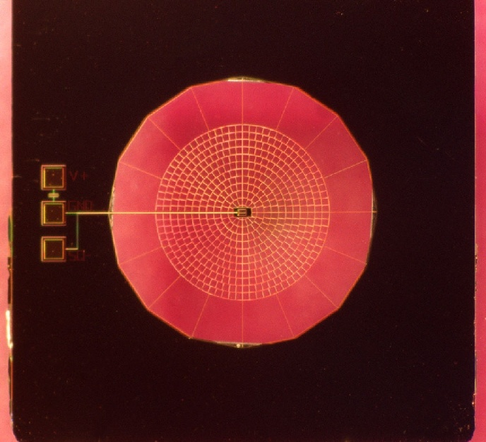
Figure 4: The spider-web bolometer design.
Further, since the spacecraft will have extended sidelobes that will deploy at L2, we will use a corrugated horn system to minimize stray light.
Large advances have been made in recent years in the production of TES detectors; arrays with > 10² pixels are currently being planned (Berkeley Bolometer Group). The total noise level is given by the combination of different noise sources, in particular detector and photon noise (noise from background optical loading). In modern detectors the photon noise dominates, thus the need to use large arrays of detectors.
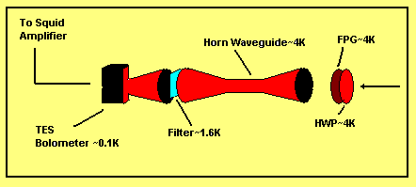
Figure 5: The beam path.
To calculate the sensitivity limits for the B-mode and SZE observations, we need to consider the noise level in the instrument. The detector noise of the TES bolometers are of the order ~2 × 10⁻¹⁷ W/sqrt(Hz) (NEP, noise equivalent power). This is comparable to the detector noise of the HFI bolometers in PLANCK. The photon noise in the instrument is complicated to determine and depends, among other things, on the transmissivity of the optics and cryostat temperature. In this feasibility study, we assume that the photon noise seen by the instrument detectors is comparable to the noise levels obtained by the HFI (PLANCK model payload). In principle, the photon noise increases with larger mirror size, but by using modern technology for the optics and cryostat and by optimizing the optical throughput, we should be able to reach at least the same photon noise.

Frequency-domain multiplexing
Large arrays of bolometric detectors require sophisticated readout schemes. To reduce thermal loading onto the coldest stages of the experiment and to reduce the complexity of instrumenting large arrays, the readout of these arrays is multiplexed. The sensor signals are read out by SQUID electronics (superconducting quantum interference device).
PI - Polarisation measurements
The main purpose of the PI is to measure extremely small fluctuations in the CMB polarization. It will use a combination of a rotating half wave plate (HWP) and a fixed polarizing grid (FPG) to modulate the polarized signal (Oxley et al., 2005). The signal is then demodulated using the recorded HWP position. This technique provides immunity to a number of instrumental systematic effects.
The HWP will rotate at a specific frequency which is chosen to match with the scanning frequency and the readout time. The use of a HWP as a polarization modulation means each detector makes independent measurements of the Stokes parameters for each pixel on the sky. No detector differencing is required.
TI – Total Intensity measurements
For the measurement of the SZ effect, we are planning to use the TI, which will measure the total intensity of the signal with resolution of 1-3 arcminutes, depending on the frequency. The detector is the same as for the PI but without the HWP and FPG.
Detector array setup
For each of the six channels there will be an array of horns/bolometers. The arrays will be constructed to fill the focal plane of the telescope with in total 690 detectors divided among the different channels and instruments (PI/TI). The size of each horn has to be larger than the wavelength of the observed radiation. To make an estimate on how many detectors can be fitted onto the focal plane we estimate that each pixel will have a size of 3 times the wavelength of the channel. The PI will go in the middle of the focal plane (the HWP will be placed in the entrance to this instrument) and contain 189 detectors, the TI will be placed in a circular segment surrounding the PI and contain 501 detectors. The predicted sensitivity limits using this setup over a mission lifetime of 5 years is given in Table 2.
Frequency (GHz) | Beamsize* (arcmin) | Sensitivity/Beam**  (μK/beam) | Number of detectors
40 (PI) | 8.6 | 3.31 | 9
100 (PI) | 3.4 | 2.64 | 36
143 (TI) | 2.6 | 3.47 | 32
220 (PI) | 1.6 | 3.14 | 144
220 (TI) | 1.6 | 2.81 | 180
330 (TI) | 1.0 | 9.22 | 289
Table 2: Important properties of the detector array.
*In some cases undersampling of the beam means the resolution may increase by a factor of 2^{1/2}.
** Calculations using NET (Noise Equivalent Temperature) values from PLANCK.
Comparing with proposed missions/telescopes (for QUIET and PolarBeaR see Table 3, Verde et al., 2005) we find that the estimated sensitivities are similar or slightly worse, but that Superman has superior resolution and sky coverage. These factors are both very important when observing CMB polarization and the SZ effect. Comparing with the upcoming PLANCK mission, we find that the estimated sensitivity is of the order of 5-10 times better. This is because of the increased number of detectors, but also the increased lifetime of the mission.
Superman will also have superior resolution to PLANCK, thus being able to resolve SZ effect to a resolution of ~1 '.
Telescope | Frequency (GHz) | Noise/Beam (μK) | Beam FWHM (‘) | Sky Coverage (sq. Deg.)
QUIET | 40 | 0.43 | 23 | 4 × 400
PolarBeaR | 90  150 | 1.6  2.4 | 6.7  4.0 | 500
PLANCK | 100 (pol)  143 | 10.9  6.0 | 9.2  7.1 | 51840

Cryogenic design
Table 3: Comparison to other experiments.
The extreme sensitivity of the bolometers (TES) used can only be obtained at the very low temperature of 0.1 K, which will be reached by a chain of cryocoolers. Each cooling system takes advantage of the previous one.
The precooling of the instrument to 50K is insured thanks to passive radiation to free space, which can be very efficient in the environment of the L2 orbit. A series of radiators thermally decouples the payload from the warm service module (~300K). The cooling chain starts, as in PLANCK, with a close cycle cooler using Joule-Thomson (J-T) expansion of hydrogen and sorption compressors which insure the cooling of the instrument to 20K. The 20K stage precools the helium in a closed loop Joule-Thomson refrigerator which provides a temperature of 4K.
Lower temperatures (to 0.1 K) are obtained by an open cycle dilution (³He/⁴He)-Joule-Thomson cooler, with a cooling power of 100nW at 0.1K. The 0.1K stage supports the bolometers assembly, band-limiting filters, thermometers and heaters. In the same process, the mixture is expanded in a Joule-Thomson valve, producing a cooling power of 100μW at 1.6K. This stage at 1.6K supports filters and intercepts heat from the 4K stage.

Power supply
The electric power for the payload instruments is generated by a circular standard solar array with an array of 11.3 m². In flight, the solar panel faces the Sun; everything else is in shadow in order to guarantee stable temperature environments.
The total power required by the spacecraft is around 800W with a total of 410W for the instrument, including 10W for the TES bolometer and the SQUIDs. At the beginning of the mission, the array is supposed to deliver approximately 3000W, and 2700W at the end of life. The power from the solar array which exceeds the system demand shall be left in the solar srray. It is also important that large circulating currents between the solar array and the spacecraft be avoided. When the available array power exceeds the total bus power demand, parts of the solar array are disconnected from the main bus and are short-circuited or re-routed to the batteries for recharging. Full protection against short-circuit or overload shall be provided by limiting the maximum current in any supply line.
Distribution among the scientific instruments and subsystems as well as the storage and conditioning of the electric power is regulated by the Power Control Subsystem (PCS), with consists of one PCDU (Power Control and Distribution Unit) and one Li-Ion Battery. The battery provides the electric power during eclipse phases with a maximum duration of 2.2h in an L2 orbit. The transition between power supply by the solar array and the battery is supposed to be continuous without main bus voltage variations.

Data amount, telemetry and telecommands
The read out raw data will be transmitted to the Signal Processing Unit, SPU, where the onboard reduction will take place. In addition to the scientific data, a header containing time, pointing and housekeeping information on the detectors will be added. The used format will be FIT, which is the standard used in astronomy. The reduced data gets transmitted further to the Digital Processing Unit, DPU where the data becomes separated into compressed entities and stored until download.
By scaling the expected values from the PLANCK mission to the number of detectors we are going to use, we came up with a data amount of 86 kbits per second. Therefore would have to transfer 7430 Mbits/day down to the ground. For telecommand, another smaller antenna with a rate of 4kbits will be used.
Using standard compression and reduction techniques e.g. as used by the PLANCK satellite, the amount of data can be cut down by a factor of about 10, which is stored in the DPU until the next communication window for telemetry, TM, and telecommand, TC. To prevent the information from possible destruction by cosmic ray impacts with the onboard memory, there is about 3 times the memory space for backups. The downlink will be initiated with a telecommand from earth.

Calibration
There are two aspects to the calibration, first the flux must be normalized with a known stable celestial source (such as Jupiter), to get the specifications of the intensity and beam shape. This is done once the spacecraft is launched. We also need to perform continuous calibration during the mission. This is achieved using the CMB dipole signal, which has been accurately measured by the COBE-FIRAS instrument, and has well known amplitude. One main advantage of using the latter type of calibration is that it does not reduce the integration time.

Scanning scheme
There are many factors that need to be taken into consideration when calculating the ‘spin’ of the satellite. We need to consider the number of data points required for each point in the sky to offer maximal coverage, the resolution (in PLANCK it goes down to 5 arcmin whereas ours has 1 arcmin resolution), and the continuous calibration requirements. The continuous calibration will be the same as in PLANCK, and requires two near simultaneous measurements of two points on the sky. Even though our satellite has a smaller angular resolution than PLANCK, which would require a higher spin, we have over 1000 detectors, as opposed to eight in PLANCK, this covers a larger patch of the sky per unit time. Thus we will be using the spin rate of PLANCK of 1 r.p.m.

The space mission

L2 Orbit
One of the main advantages of an L2 orbit is the possibility of uninterrupted observations, since the Earth, Moon and the Sun remain always behind this point and, therefore, behind the satellite. Since the L2 point moves around the Sun, keeping pace with the Earth, the entire celestial sphere can be scanned within the course of one year. In addition the Lagrange point offers a stable low-temperature environment.

Description of the spacecraft
The design of our spacecraft follows the basic configuration of PLANCK, but the scales are different. The solar panel has a diameter of 3800 mm. On top of the panels, the service module (SVM) is located, having a diameter of 2560 mm and a height of 970 mm. The next stages consist of the ‘V-grooves’ (700 mm height, 2800 mm width) for thermal insulation and shielding between the warm SVM (300 K) and the cold (50 K) payload. The V-grooves are then followed by the actual telescope (4833 mm height). Thus, the total length of the spacecraft is 6503 mm and the maximum width is 3800 mm. The Soyuz ST fairing, that we had to fit our spacecraft into, has an outer diameter of 4110 mm and a length of 9518 mm. Therefore, our spacecraft fits into the Soyuz fairing.
A special feature of our spacecraft, which is not present in PLANCK, is the extension of the V-grooves by deploying glass fiber-reinforced plastic panels (GFRP-panels), the so called ‘Tulip’. They must have a very blank metal surface (thermal emission, ε=0.03), which can be achieved by gold evaporation. Before the launch it is fixed by a hold down mechanism.

Mass estimate
Because our design is based on PLANCK the different in mass was mainly due to the bigger mirror and a different instrumentation. The constraint according to the total mass was given by using the Soyuz-Fregat launcher capable to transport a mass of 2200kg to the L2 orbit.

Choice of the Launcher
For our study we consider to use a Soyuz-Fregat launcher. The decision was predominantly constrained by following factors:
- The cost of the launch of approximately 50M€ considering our design of a medium size mission.
- The capability of the launcher to reach the required L2 orbit.
- The capability of the Soyuz-Fregat to transport a mass of 2200kg.

The planned mission duration is five years. The length of the mission is closely correlated with our sensitivity limit as a longer integration time gives a better signal. We will be going to an orbit around the second Lagrange point (L2) with the Soyuz as launcher. This orbit is the most suitable one for the mission as we want full sky coverage and it gives stable conditions where effects from the Sun, Earth and Moon are minimized. Our satellite fits into the Soyuz bay volume and the Soyuz is capable of getting it into the chosen orbit at a relatively low cost, compared to larger missions.

Space-borne and ground-based receivers
For communication with the space probe, two antennas are used, a Medium Gain Antenna, MGA, for the telemetry and a Low Gain Antenna for the telecommand. The LGA is independent of the attitude of the space probe. Therefore, communication with the space probe can be achieved even if it the MGA loses its orientation towards Earth.
For cost reasons, we will use only one ground station. The maximal window for telemetry/telecommand lasts for 8 hours. Depending on which receiving antenna we use and which elevation above ground the antenna can cover the transmission, the window can get cut down to 3 hours. Since the position of a space probe in L2-Orbit is always close to or even on the ecliptic, an antenna more or less close to the equator should be chosen, which is at least 35 m in diameter.
By using the high transmission rate of 1,5 Mbits/sec, we will be able to do the whole transmission within 1.4 hours and therefore have a time margin to do a second transmission for a major part of the data in case the transmission of Compressed Entities fails.
Based on these assumptions, we will also choose the already selected antennas for the PLANCK mission: New Norcia, and Kourou as a backup.

Ground segment
The ground segment for SUPERMAN consists of two major elements, the Operation Ground Segment, OGS and the Science Ground Segment, SGS.
The OGS provided by ESA will implement the observation and scanning plan within the spacecraft system performing all classical spacecraft operations along with maintenance tasks.
The SGS will be done by the SUPERMAN Science Data Centre (SSDC). The SSDC is responsible for the science telemetry, plus the relevant ancillary spacecraft data from the OGS, and transforming the data transmitted from the spacecraft into a “scientist handy” form and distribute it to them. The second goal for the SSDC is to realize the data archive and improvement on algorithmic reduction.

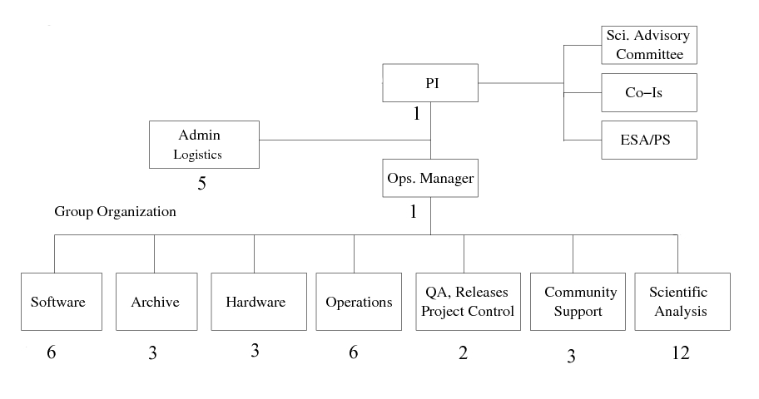
Ground control
Figure 6: A flowchart showing the proposed organisation with the estimated number of personnel in each group.
A principal investigator will head the team and will in addition take care of communications with the scientific advisory committee and ESA. The operations manager will take care of every day running of the project and head the various subteams. The subteams will consist of a software team which will write the needed software for reducing data, the archive team which will be responsible for storing the data from the survey in accessible form, a hardware team, the operations team which will take care of satellite operations, a QA team, community support and finally, the largest team will deal with scientific analysis.

Cost estimate
Our platform and payload are based on the preexisting designs for PLANCK with appropriate modifications to suit our science goals. With this taken into consideration, we expect the cost of our payload to be around 200 M€ and the SVM (service module) to amount to 150 M€. The launch will be done by the Soyuz from Kourou and the estimated cost is 50 M€. In addition, we estimate a cost of 20 M€ for ground testing and a 35 M€ mission operations over the planned five year mission time. In total, the mission is estimated to cost 455 M€ making it a medium-sized mission.

Acknowledgements
Many thanks go out to Niels Lund, Denis Moura, Andreas Quirrenbach, Andrea Santovicenzo, Martin Turner, and all the other tutors and lecturers at the Alpbach 2005 Summer School for invaluable help on so many different aspects of the mission.

References
Bartelmann, Doran and Wetterich, 2005, astro-ph/0507257
Berkeley Bolometer Group http://bolo.berkeley.edu/polarbear/,
Birkinshaw, Physics Reports, 1999, 310:97-195
Boomerang Mission Description, http://cmb.phys.cwru.edu/boomerang
Carlstrom, Holder and Reese, Annu. Rev. Astronomy & Astrophysics, 2002, 40, 643
Da Silva et al., 2000, MNRAS, 317, 37
Diaferio, Nusser, Yoshida and Sunyaev, 2003, MNRAS, 338, 433
Diethart, Cornelia “The Design and Usage of the Detector Selection Software at Herschel/PACS”, Diploma thesis, 2005, Department for Astronomy of the University of Vienna
Dragone, C., 1982. IEEE Trans.Ant.Prop. 3, 331
Hanany, S., Marrone, D.P., 2002. Applied Optics 41, 4666-4670
http://cmb.phys.cwru.edu/boomerang,
http://www.cmbfast.org/, 25.07.2005.
Hu and White, “A CMB Polarization Primer”; arXiv: astro-ph/9706147
INTEGRAL Ground Segment, http://integral.esac.esa.int/integ_ground_segment.html
Kesden et al., Phys.Rev. D66 (2002) 083007
Knox and Song, Phys.Rev.Lett. 89 (2002) 011303
Kosowsky, 2004, astro-ph/0402234
Lange, “Detectors for future CMB observations”
Liddle and Lyth, “Cosmological Perturbations and Large Scale Structure”; Cambridge University Press, 2000.
Mizuguchi, Y. et al., 1978. Electrical.Comunications in Japan 61-B 3, 58
Oxley et al., “The EBEX experiment” 2005, arXiv:astro-ph/0501111
P. Oxley et al., “The EBEX Experiment”, arXiv:astro-ph/0501111
Padmanabhan and Finkbeiner, “Detecting Dark Matter Annihilation: Signatures and Experimental Prospects”; arXiv: astro-ph/0503486 (submitted to PRD)
PolarBear Mission Description, http://bolo.berkeley.edu/polarbear/
Predehl et al., 2003, AN, 324, 128
Press and Schechter, 1974, ApJ, 187, 425
Sadeh and Raphaeli, 2005, astro-ph/0507506
Seljak and Hirata, Phys.Rev. D69 (2004) 043005
Sunyaev and Zel’dovic, Comments Astrophys. Space Phys., 1970, 2:66-74
Sunyaev and Zel’dovic, Comments Astrophys. Space Phys., 1972, 4:173-78
Taylor et al.,”CLOVER – A new instrument for measuring the B-mode polarization of the CMB” Proceedings of the XXXVIXth Rencontres de Moriond “Exploring the Universe”, 2004.
Tegmark et. Al., Phys. Rev. D 69,103501 (2004).
The model payload of PLANCK (http://www.rssd.esa.int/SA/PLANCK/include/payl/redbook-payload.html)
The model payload of PLANCK (http://www.rssd.esa.int/SA/PLANCK/include/payl/redbook-payload.html)
Tucci et al., MNRAS 360 (2005) 926-934.
Verde et al., “Optimizing CMB polarization experiments to constrain inflationary physics”, submitted to MNRAS, astro-ph/0506036.
Verde et al., 2005, arXiv:astro-ph/0506036
Wetterich, “Dark Energy II: Quintessence”, talk at the Alpbach 2005 summer school.

